ZH Full Color Sync & Async Manual
(Applies to Model: ZH-XM/C580L/C600/C700/C800）

I. Create A New Screen
1. First, double clicking 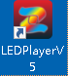 to open the software, select the Asynchronous Mode in the software mode interface and click "Yes".

- Under the Create Screen Dialog” interface, choose the suitable model ZH-XXX in “ Screen Type ” . Set the width and height of the display, and click “OK.”.

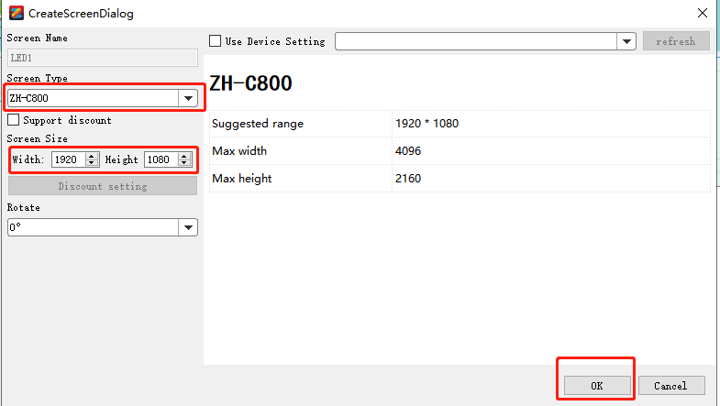

II. Screen Set

- Click “ Setting ”---“ Display settings”

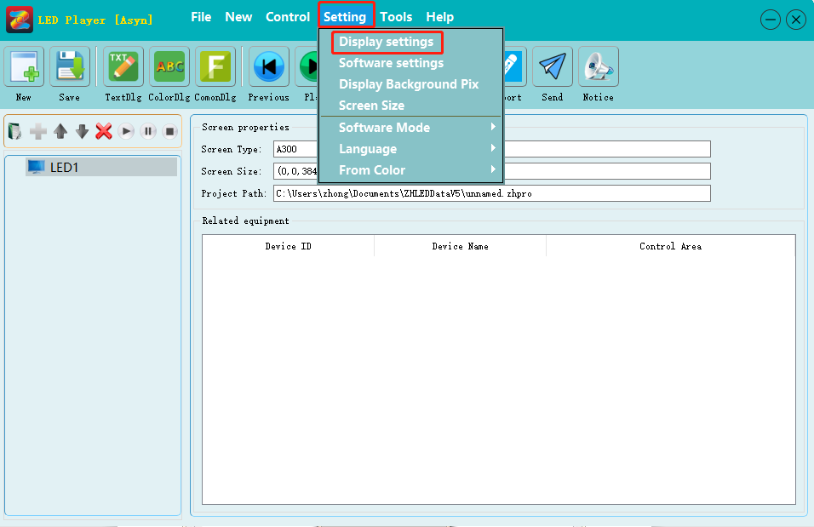
- After the device information refreshed, click the setting button and enter the password 168.

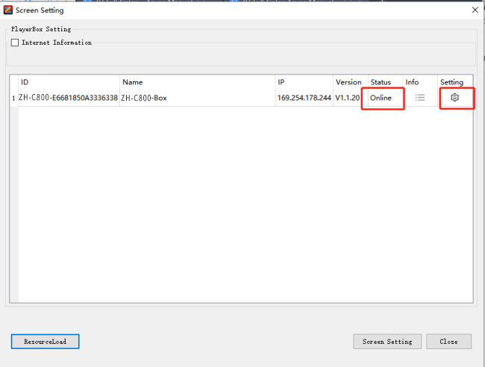
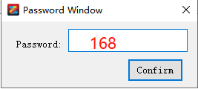

- Choose the appropriate resolution (The height and width of the resolution must be larger than or equal to the actual height and width of the screen at the same time), then click “ Set ”.
Note: After changing the resolution, the device will automatically restart, and the software will automatically close this interface. after the device restart, can enter into the page for other settings.

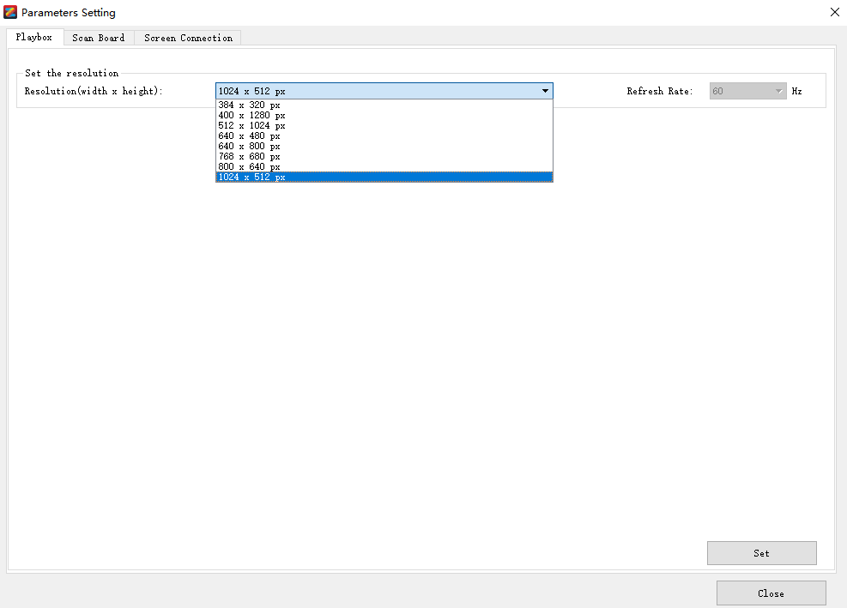

- Click “ Scan Board ”, select the suitable model type.

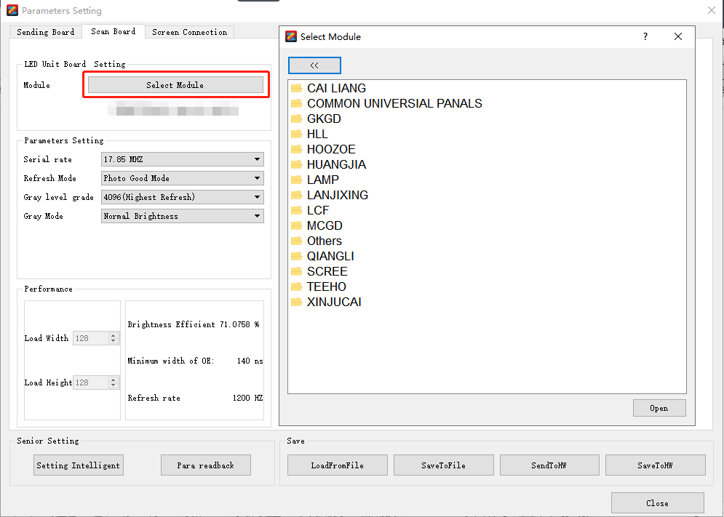

- Click “ Screen Connection ”, configure the connection relation of the corresponding receiving card, send to the hardware, and save to hardware.
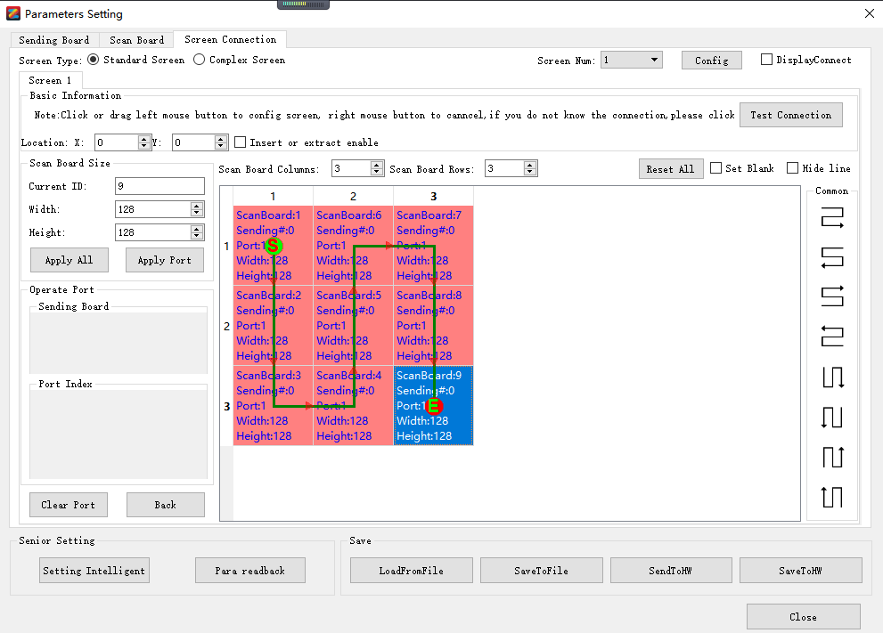

Note: Single network cable max loading 650,000 points, the max height: 1024, and the max width: 2048. When exceeding, multiple network ports are required, when configuring, first select the serial port number, then configure the connection relationship, and then send it to the hardware, and then save to the hardware.

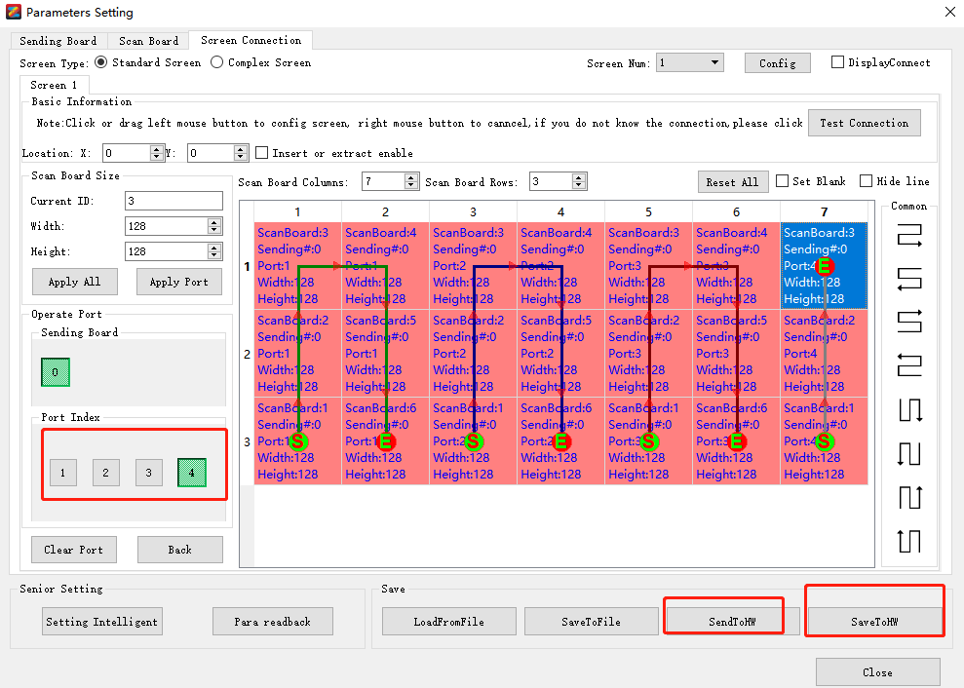

After the above steps are completed, the display screen will display normally.

III. Edit Content
Click “ New ” --- “File Window”, and add materials.

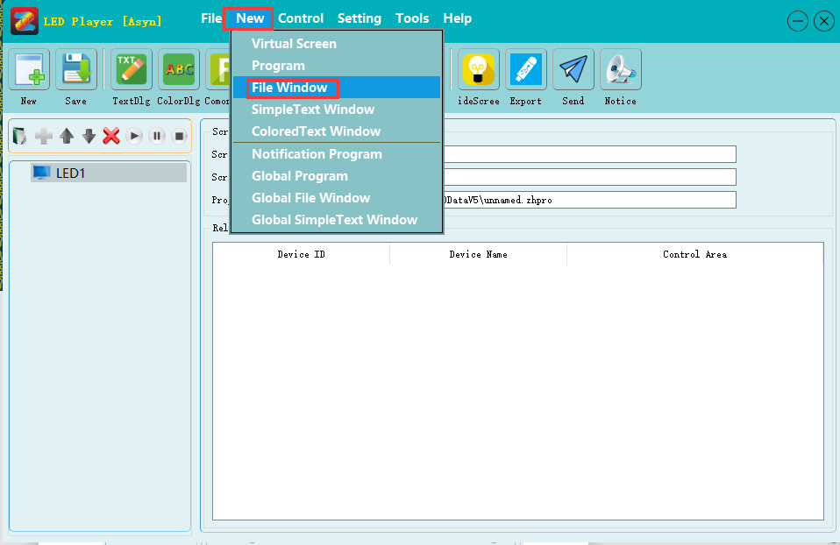
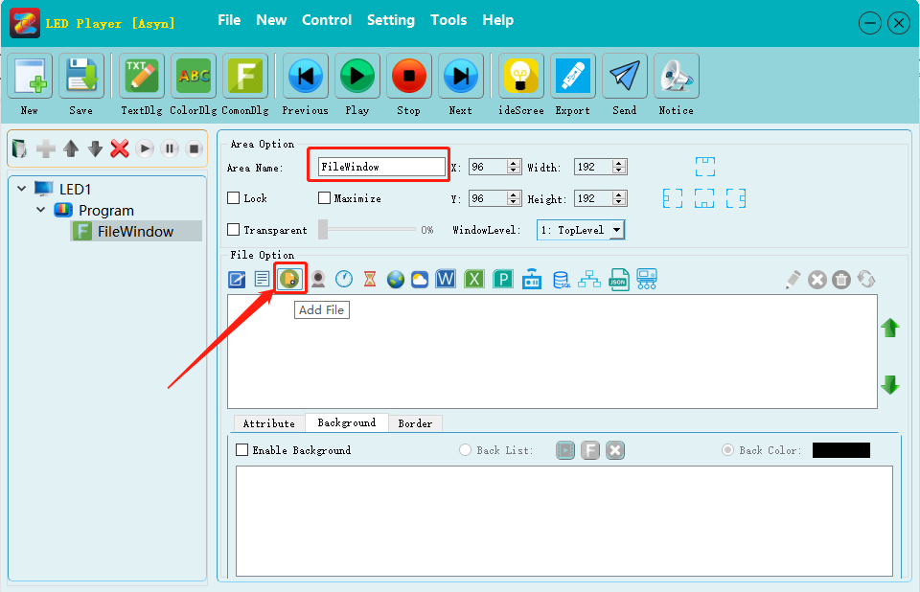

IV. Upload Content

- U disk Upload Content
①U disk export: click the “Export” button in the top right corner of the software.

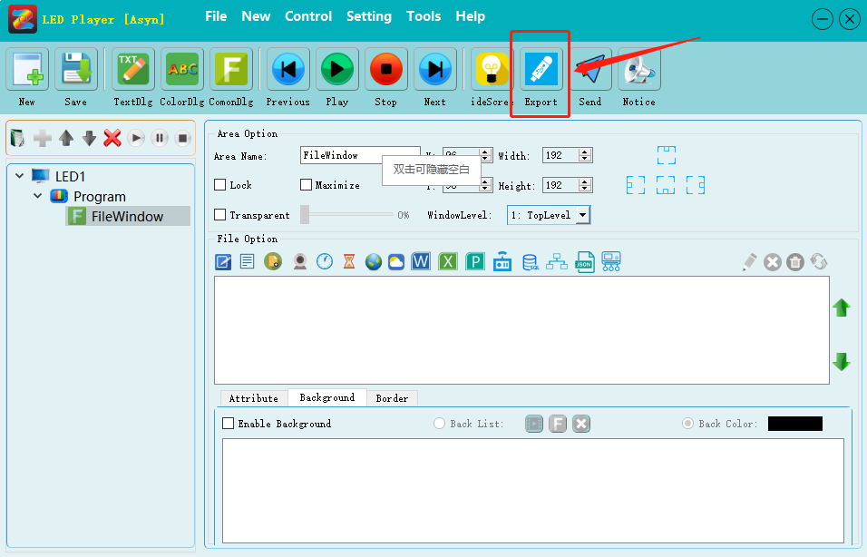
②Enter the export interface, if you have add time, please click “Time correction”, then click “Export”.
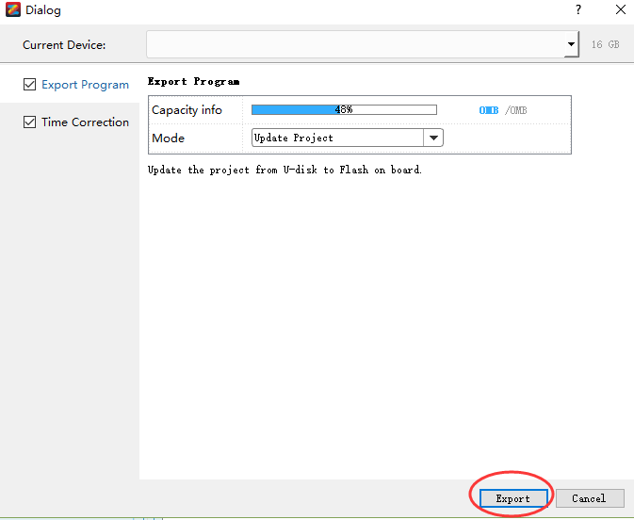
③After back up is finished, click “ok”, then unplug U disk and plug into led display screen.

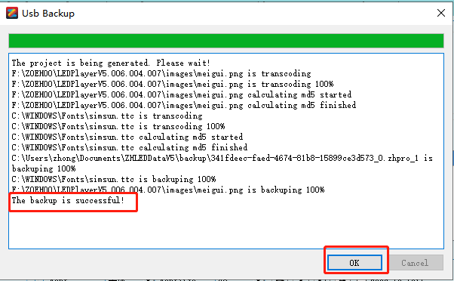

- LAN Cable Send Content
①Click the “Send” button in the top right corner of the software.
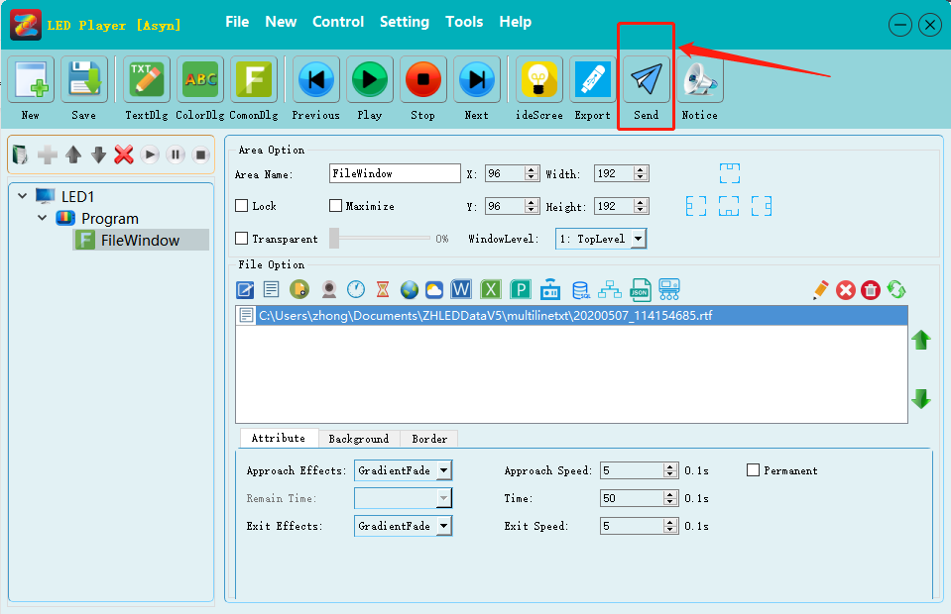
②After the transcoding is completed, the sending interface will pop up, select the corresponding device, and click “ Send ” to send the content.

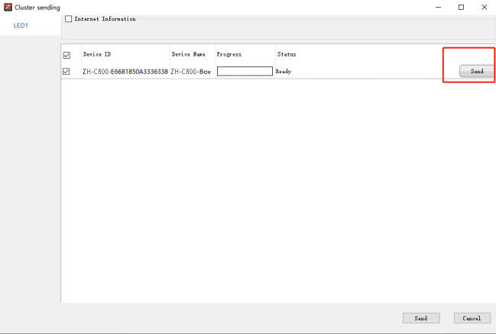

- WiFi Send Content

Due to information security issues, the factory default WiFi is closed. Therefore, customers need to turn on WiFi manually. The steps are as follows:

⑴. Using Ethernet cable line to open WiFi:
① Click “Control--Asynchronous Management”.

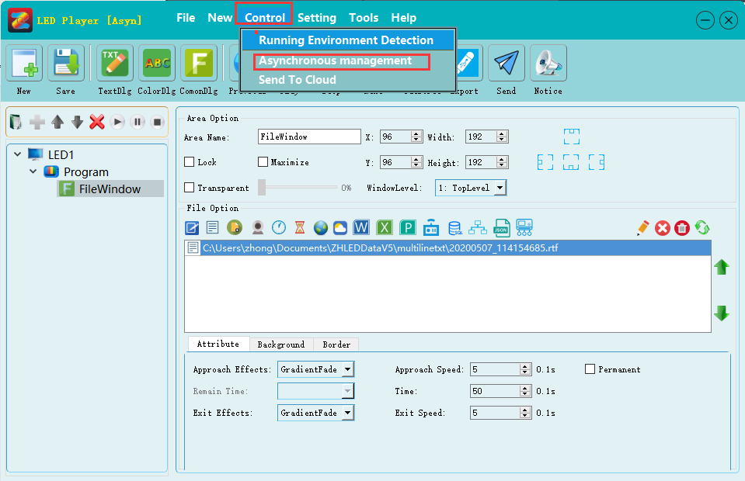
② Choose the device, and click “ WIFI setting ”.
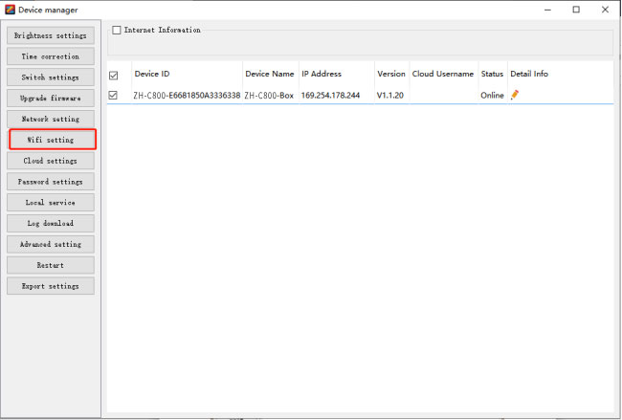
③Choose “Enable”, make sure the WiFi name and password, then click “setting”.

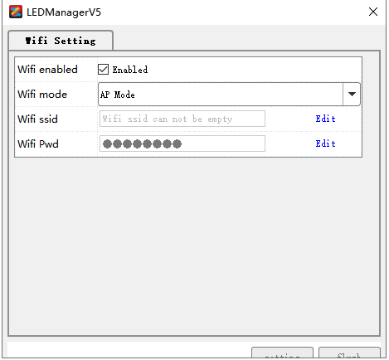

④After link this WiFi can send content. (For the steps, please refer to the network cable sending)

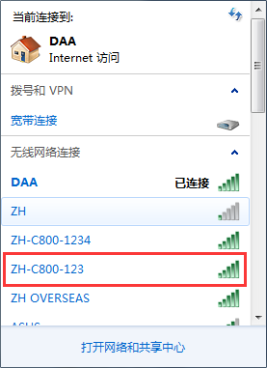

⑵. Using U-disk to open WiFi
① Click “Control--Asynchronous Management”.
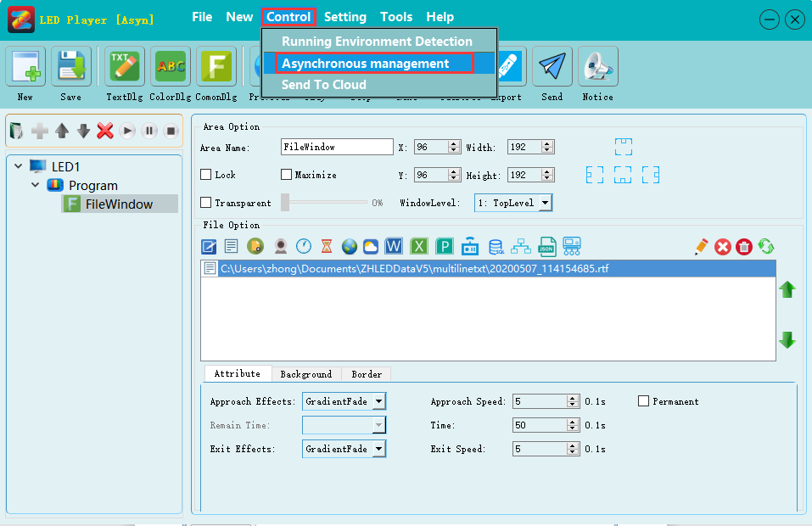
② Select the device and click “ Export settings ”.
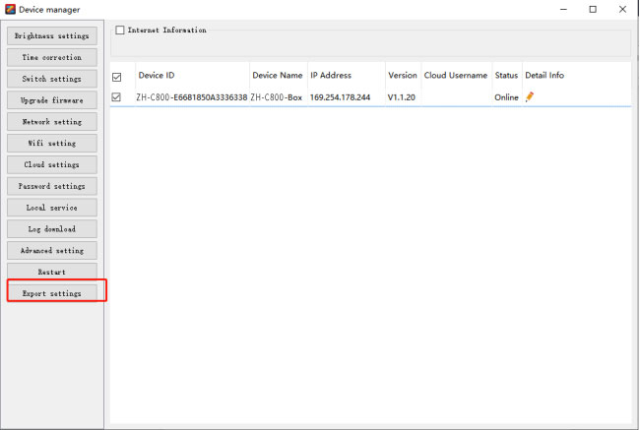③Choose “Network Setting ” --- “WiFi Setting” --- “Enable”, make sure the WiFi name and password, then click “Export”--- “OK”.

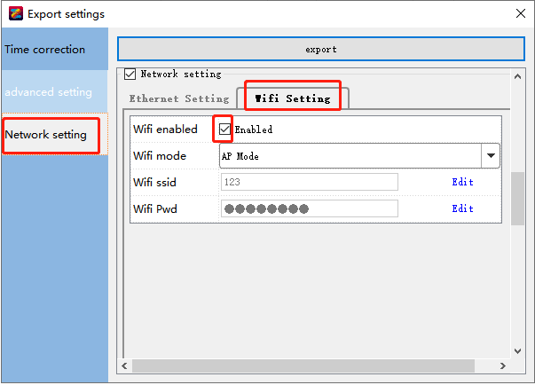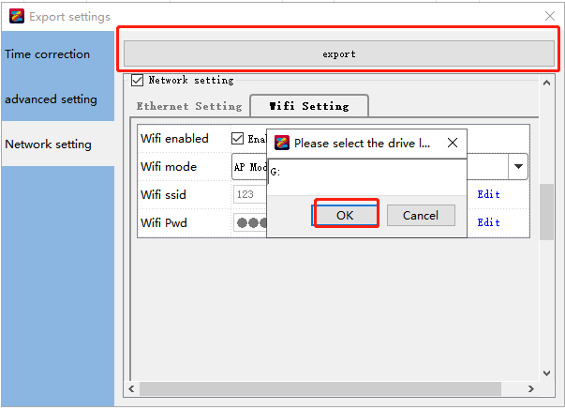
④After link this WiFi can send content. (For the steps, please refer to the network cable sending)

